

BOT FOR WILDLIFE PROTECTION

Submitted by

Vancha Ankitha Reddy(20BCT0041)

vanchaankitha.reddy2020@vitstudent.ac.in

Unna Jitendra(20BCT0217)

[unna.jitendra2020@vitstudent.ac.in](mailto:sujithreddy.c2020@vitstudent.ac.in)

Konreddy Kishan Kumar Reddy(20BCT0253)

konreddy.kishankumar[020@vitstudent.ac.in](mailto:gajula.padmatej2020@vitstudent.ac.in)

Under the guidance of

Dr.Prof.Jafar Ali Ibrahim

[jafarali.s@vit.ac.in](mailto:jafarali.s@vit.ac.in)

BOT FOR WILDLIFE PROTECTION

We are coding with Arduino IDE software and sending the code through cable wire to the Arduino Uno. In order to detect any barriers or people in front of the robot, we use that code and link the ultrasonic sensor to the Arduino. It perceives, and it automatically alters its route. Many individuals who don't know how to drive a car safely can benefit from our effort, and it will assist in the decrease of accidents caused by them.

2. MOTIVATION

Wildlife plays a vital role in the world’s ecosystem as it provides balance and stability to nature’s processes. Wildlife conservation is to protect the habitats of various plants and animal species and prevent these species from going endangered or extinct which would affect the balance of the ecosystem. The goal of wildlife conservation is to ensure the survival of these species and to educate people on living sustainably with other species. Hence we thought why not use the growing technology considered bane to wildlife be changed boon to wildlife .To Protect wildlife by continuously monitoring the activities of endangered animals and keeping an eye on endangered plants. We can save animals with our project.

ABSTRACT:

A robot is a device that can carry out human-like functions.It is the most sophisticated branch in electromechanics, and engineers have made incredible strides in the past 10 years. We still have a lot of work to do in the field. In the project, we'll build a little robot that will be a BOT for animal conservation that will demonstrate how technology development may benefit wildlife. Practising conservation also lowers the likelihood of accidents.To Protect wildlife by continuously monitoring the activities of endangered animals and keeping an eye on endangered plants. For the purpose of controlling the ultrasonic sensor's directions, we must utilise an Arduino Uno and programme it.This robot will use an ultrasonic sensor to detect people or obstructions, and it will make a choice to adjust its course appropriately.

keyword:

Bot car,Arduino uno,ultrasonic sensors,motor drives,wearable devices,obstacles,

Independent,Social impact.

1.INTRODUCTION

These days, people may use a variety of sensors and sophisticated technologies to detect accidents, but the majority of them are hard to travel and require substantial training. We are here to present our proposal to lessen the number of accidents caused by people's negligence. To build a bot, we must build a vehicle with a battery, motor, and static parts like an Arduino and an ultrasonic sensor.

Ultrasonic sensor(HC-SR04)

A transistor receiver, a transceiver, and a transmitter make up the ultrasonic sensor. The transceiver, which is typically the receiving item, does both the transistor and receiver jobs. The transistor changes electrical signals into soundwaves, the receiver transforms soundwaves from the obstacle into electrical signals. Basically, it uses the sound waves produced to help measure the distance to an obstruction.

These 5 steps occurs in ultrasonic senor

a)Ultrasonic signal received by the sensor.

(b) Filtered signal.

(c) Envelope

(d) Envelope raised to the third power.

(e) Resulting amplified signal and threshold level.

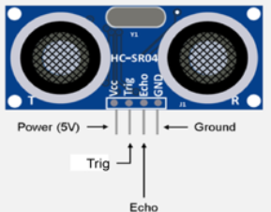

Battery:

The positive terminal of a battery is referred to as the cathode, while the negative end is referred to as the anode, when it is delivering electricity. The positive terminal will receive electrons from the negative terminal through an outside electric circuit.

We used an ultrasonic sensor which is used to avoid the collision which will not harm any animals. We can use this idea to protect flora and fauna from illegal hunting and poaching. We can protect forests from fires by using sensors in the bot. We can use other sensors to detect smoke. It can measure the quality of air and water. It is very useful because it can roam from different places. It is just like a car.

3. SUPPORT SYSTEM

The support system helps in the accurate and efficient identification of barriers surrounding the device, which has a wide detection area. It is made up of a number of parts that work together to make it whole.

* Arduino UNO
* Ultrasonic Sensor(HC-SR04)
* Battery
* Switches
* Hot Glue
* Motor drives
* Wheels
* Male female wires
* Plastic board

Arduino Uno:

The Arduino is a computer programme that combines hardware and software to build electrical projects. Microcontrollers like the Arduino include extra functionality like GPIO pins and a USB port.

SOFTWARE:

Tinkercad:

Tinkercad is a free, online 3D modelling program that runs in a web browser, known for its simplicity and ease of use. It became available in 2011 since then it has become a popular platform for creating models.

Arduino IDE software:

Arduino UNO is one of the greatest programming software for all of the above-mentioned operations that complete the total project. The Arduino software is written in the C++ programming language, with some extra unique functions and methods added.To built any project we need to write the code and upload it on the board. The open-source Arduino Software (IDE) makes it easy to write code and upload it to the board and it can be used with any Arduino board.

A redox process takes place when a battery is connected to an external electric load, turning high-energy reactants into lower-energy products and supplying the free-energy difference as electrical energy to the external circuit. The phrase "battery" used to refer to a device made up of several cells, but it has now evolved to refer to items made up of just one cell.

Motor drives:

The drive, also known as the electric drive or motor drive, is the apparatus that houses the motor and causes it to rotate. There are several names for motor drives, including AC drives, variable frequency drives, variable speed drives, adjustable frequency drives, inverters, and power converters.

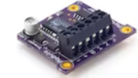

Switches:

These switches are used to link the battery and wheels, supplying power from the battery to the wheels to power the robot.

6.Code:

#include <AFMotor.h>

#include <NewPing.h>

#include <Servo.h>

#define TRIG_PIN A0

#define ECHO_PIN A1

#define MAX_DISTANCE 200

#define MAX_SPEED 190 // sets speed of DC motors

#define MAX_SPEED_OFFSET 20

NewPing sonar(TRIG_PIN, ECHO_PIN, MAX_DISTANCE);

AF_DCMotormotor1(1,MOTOR12_1KHZ);

AF_DCMotormotor2(2,MOTOR12_1KHZ);

AF_DCMotormotor3(3,MOTOR34_1KHZ);

AF_DCMotormotor4(4,MOTOR34_1KHZ);

Servo myservo;

boolean goesForward=false;

int distance = 100;

int speedSet = 0;

void setup() {

myservo.attach(10);

myservo.write(115);

delay(2000);

distance = readPing();

delay(100);

distance = readPing();

delay(100);

distance = readPing();

delay(100);

distance = readPing();

delay(100);

}

void loop() {

int distanceR = 0;

int distanceL = 0;

5. SYSTEM ARCHITECTURE:

The Arduino UNO is prepared to establish a connection with the ultrasonic sensor. The input signal from the ultrasonic sensor is sent to the Arduino, which has the necessary coding input to carry out the desired or necessary activities.the output from arduino captured and the ultrasonic sensors changes its direction from obstacle.The main part is to construct a bot and connect these system required tools and give input through arduino ide software to program the code in arduino .We can simulate the output using Tinkercad, and using the Online tool, we can display our simulation work.

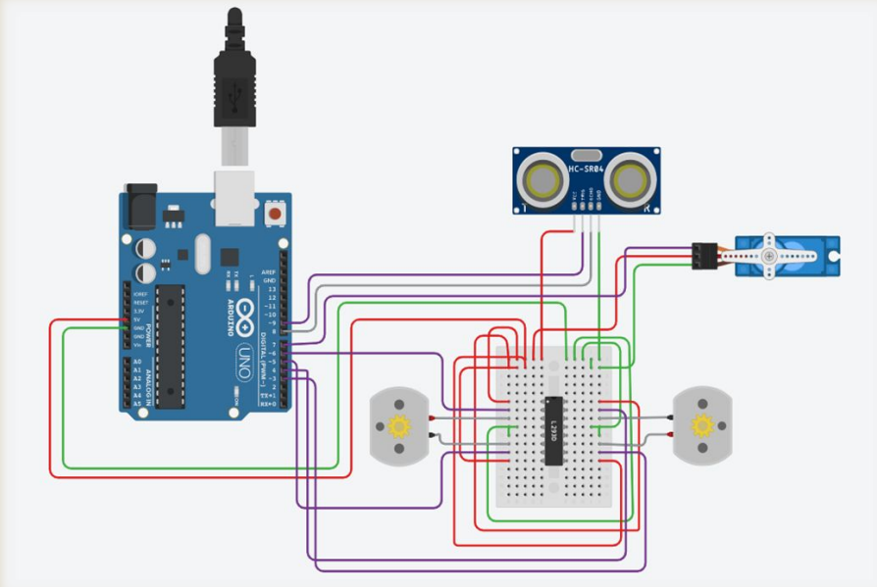

5. WORKING PRINCIPLE:

This gadget has an ultrasonic sensor, which detects obstructions, people, or wild animals, and dynamically calculates direction away from the impediment.It generates a vibration, alters its course to avoid the obstruction, and also helps novice learners avoid mishaps.

.

}else

{

turnLeft();

moveStop();

}

}else

{

moveForward();

}

distance = readPing();

}

int lookRight()

{

myservo.write(50);

delay(500);

int distance = readPing();

delay(100);

myservo.write(115);

return distance;

}

int lookLeft()

{

myservo.write(170);

delay(500);

int distance = readPing();

delay(100);

distance = readPing();

delay(100);

distance = readPing();

delay(100);

distance = readPing();

delay(100);

}

void loop() {

int distanceR = 0;

int distanceL = 0;

delay(40);

if(distance<=15)

{

moveStop();

delay(100);

moveBackward();

delay(300);

moveStop();

delay(200);

distanceR = lookRight();

delay(200);

distanceL = lookLeft();

delay(200);

if(distanceR>=distanceL)

{

turnRight();

moveStop();

for (speedSet = 0; speedSet < MAX_SPEED; speedSet +=2) // slowly bring the speed up to avoid loading down the batteries too quickly

{

motor1.setSpeed(speedSet);

motor2.setSpeed(speedSet);

motor3.setSpeed(speedSet);

motor4.setSpeed(speedSet);

delay(5);

}

}

}

void moveBackward() {

goesForward=false;

motor1.run(BACKWARD);

motor2.run(BACKWARD);

motor3.run(BACKWARD);

motor4.run(BACKWARD);

for (speedSet = 0; speedSet < MAX_SPEED; speedSet +=2) // slowly bring the speed up to avoid loading down the batteries too quickly

{

motor1.setSpeed(speedSet);

motor2.setSpeed(speedSet);

motor3.setSpeed(speedSet);

myservo.write(115);

return distance;

delay(100);

}

int readPing() {

delay(70);

int cm = sonar.ping_cm();

if(cm==0)

{

cm = 250;

}

return cm;

}

void moveStop() {

motor1.run(RELEASE);

motor2.run(RELEASE);

motor3.run(RELEASE);

motor4.run(RELEASE);

}

void moveForward() {

if(!goesForward)

{

goesForward=true;

motor1.run(FORWARD);

motor2.run(FORWARD);

motor3.run(FORWARD);

motor4.run(FORWARD);

We have tested this code using the Arduino IDE program, and we've included some images below to help you see.

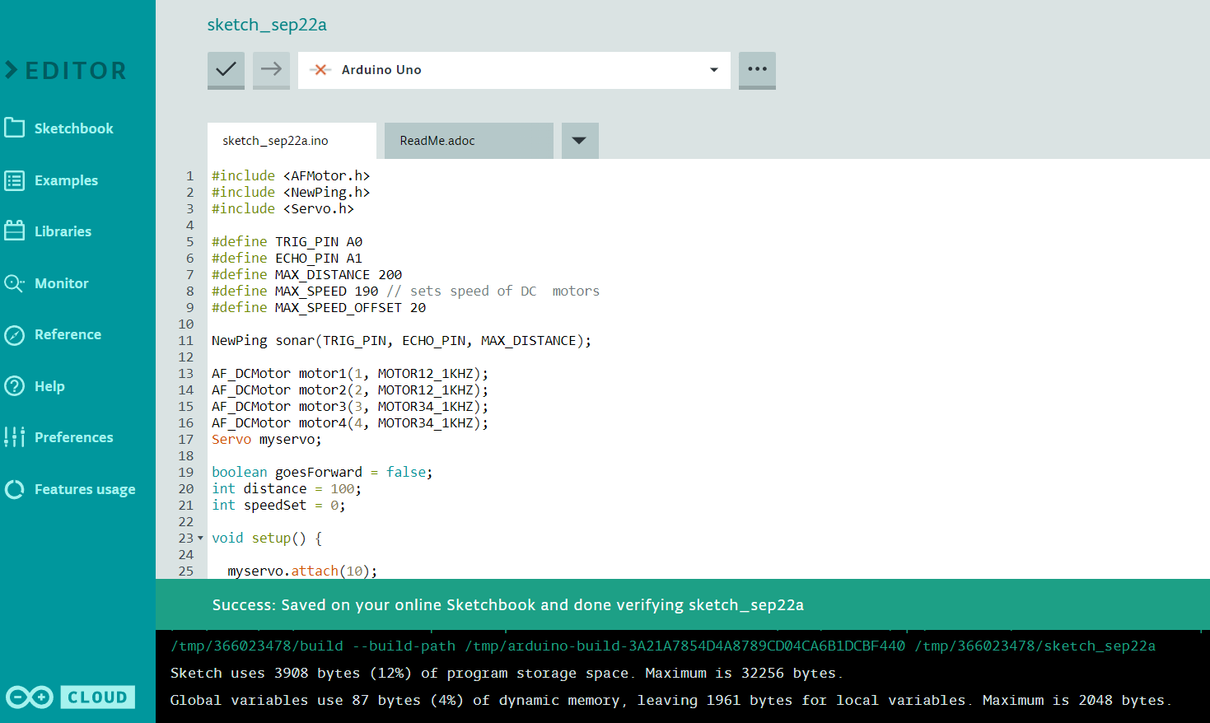

Select the board and port in Arduino IDE software :

motor4.setSpeed(speedSet);

delay(5);

}

}

void turnRight() {

motor1.run(FORWARD);

motor2.run(FORWARD);

motor3.run(BACKWARD);

motor4.run(BACKWARD);

delay(500);

motor1.run(FORWARD);

motor2.run(FORWARD);

motor3.run(FORWARD);

motor4.run(FORWARD);

}

void turnLeft() {

motor1.run(BACKWARD);

motor2.run(BACKWARD);

motor3.run(FORWARD);

motor4.run(FORWARD);

delay(500);

motor1.run(FORWARD);

motor2.run(FORWARD);

motor3.run(FORWARD);

motor4.run(FORWARD);

}

The relative speed estimated by the control system from consecutive samples of the distance, along with the corresponding filtered signal.

The control signal which acts on the throttle when it is positive or on the brake when it is negative, along with the corresponding filtered signal. Initially, the controller acts at 5% on the throttle, which is not enough to initiate the movement. The final action is about 10% on the brake, which keeps the vehicle at rest.

8.CONCLUSION:

As a result, the project that our team created completely explains the model and architecture of an Arduino-based robot used for wildlife protection and accident reduction. This bot is very useful in the future to protect our wildlife sanctuary and to save the forest and animals. It can protect animals from accidents by using ultrasonic sensors.

Finally Run the code we will get the success and attach the arduino message will popup on screen.

7.EXPERIMENTAL RESULTS:

The controller parameters obtained by the GA have been manually adjusted for safety, to slightly reduce the action on the accelerator, because the mathematical model does not match the vehicle used for testing, for which no model was available. Several tracking tests were performed with satisfactory results.

The distance between vehicles as measured by the ultrasonic system, where detection failures and false echoes caused by turbulence can be seen.

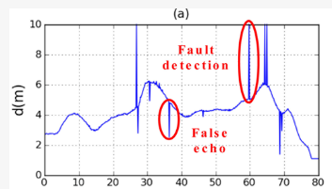

The speeds of the vehicles, both starting from rest at a distance of about 3 m, and both ending up at rest at a distance slightly greater than 1 m.

THANK YOU

[6] Short, M.; Pont, M.J.; Huang, Q. Simulation of Vehicle Longitudinal Dynamics; Embedded Systems Laboratory, University of Leicester: Leicester, UK, 2004.

[7] Holland, J.H. Adaptation in Natural and Artificial Systems; MIT Press: Cambridge, MA, USA, 1992.

[8] Autopia. Available online: http://www.iai.csic.es/users/autopia/programa_en.html (accessed on September 15, 2010).

[9] Hari Chandan T., Shamanth Nagaraju, Bharath Nandan Varma, Kiran Kumar M., Manasa S., Mukund K. V., "IoT based Vehicle Over-Speed Detection and Accident Avoidance System", *2021 International Conference on Disruptive Technologies for Multi-Disciplinary Research and Applications (CENTCON)*, vol.1, pp.112-117, 2021.

[10] Manish Kumar, Akshat Kant, Punit Kaktan, Ramesh Bishnoi, Kapil Upadhyay, "Arduino Based System to Prevent Vehicle Accidents", *2021 International Conference on Design Innovations for 3Cs Compute Communicate Control (ICDI3C)*, pp.140-144, 2021.

[11] R. Bharathi, Sunanda Dixit, R. Bhagya, "Modern Automobile Adaptive Cruise Control", *International Conference on Innovative Computing and Communications*, vol.1165, pp.1109, 2021.

Using the Arduino IDE programming environment, we write code that is sent to the Arduino Uno via cable. We use that code and connect the ultrasonic sensor to the Arduino to identify any obstacles or persons in front of the robot. We are not planning to just end it here. As of now , it is just a sensor detection bot ,we are trying to show live data and record data through the bot.

9.REFERENCES:

[1] Observatorio Nacional de Seguridad Vial. Anuario Estadístico de Accidentes 2009; Dirección General de Tráfico, Ministerio del Interior: Madrid, Spain, 2008.

[2] Onieva, E.; Milanés, V.; González, C.; de Pedro, T.; Pérez, J.; Alonso, J. Throttle and brake pedals automation for populated areas. Robotica 2010, 28, 509-516.

[3] Kinsler, L.E.; Frey, A.R.; Coopens A.B.; Sanders, J.V. Fundamentals of Acoustics, 4th ed.; Wiley: New York, NY, USA, 2000.

[4] Alonso, L. Contribuciones al estudio de sistemas ultrasónicos y su aplicación a la seguridad activa en vehículos inteligentes. Ph.D. Thesis, University of Cantabria, Cantabria, Spain, 2009.

[5] Alonso, L.; Pérez-Oria, J.M.; Fernández, M.; Rodríguez, C.; Arce, J.; Ibarra, M.; Ordoñez, V. Genetically tuned controller of an adaptive cruise control for urban traffic based on ultrasounds. In Artificial Neural Networks—ICANN 2010; Lecture Notes on Computer Science; Springer: Berlin/Heidelberg, Germany, 2010; Volume 6353/2010, pp. 479-485.